**Task 23: MySQL**

1. Creating database Employee_Details:

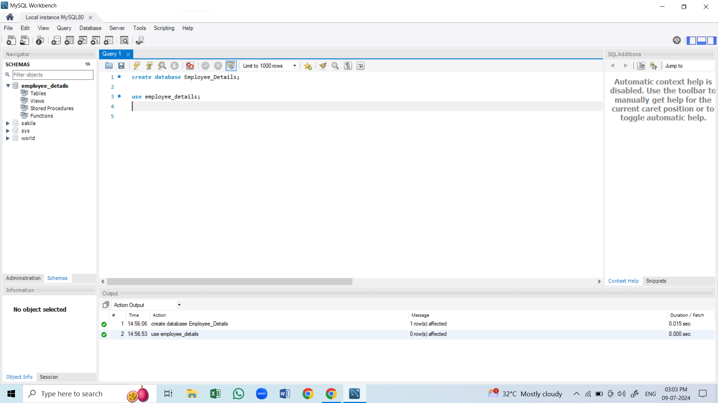

1. Create table empl

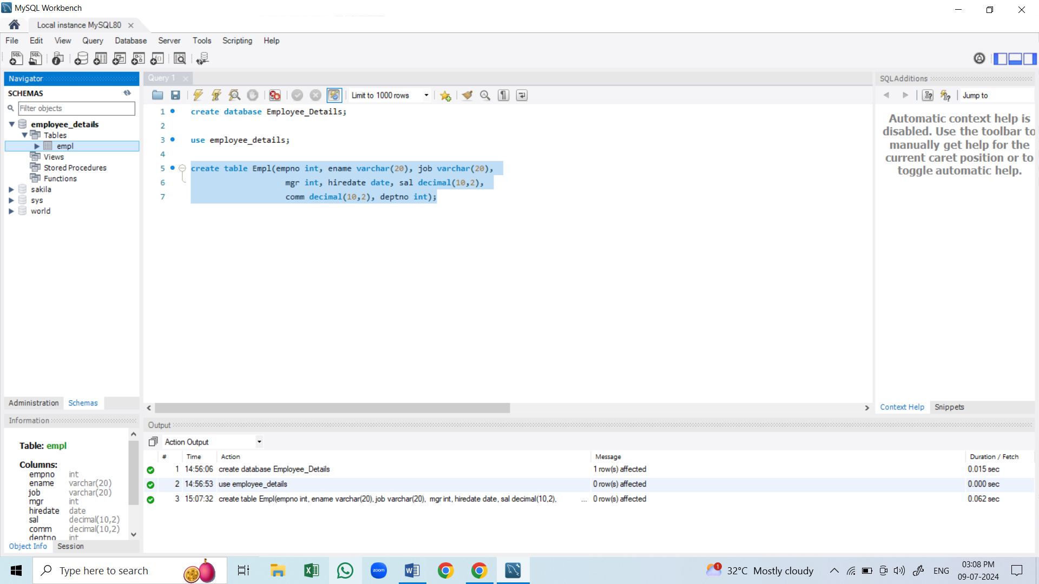

1. Insert data to the empl table

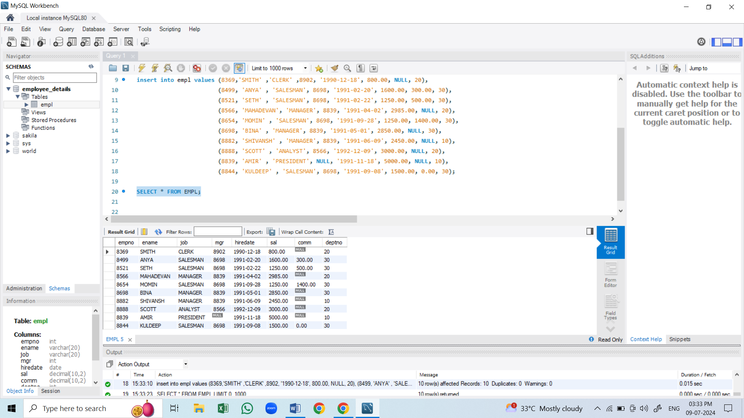

Question 1:

1. Write a query to display ename and sal of employees whose salary is greater than or equal to 2200?

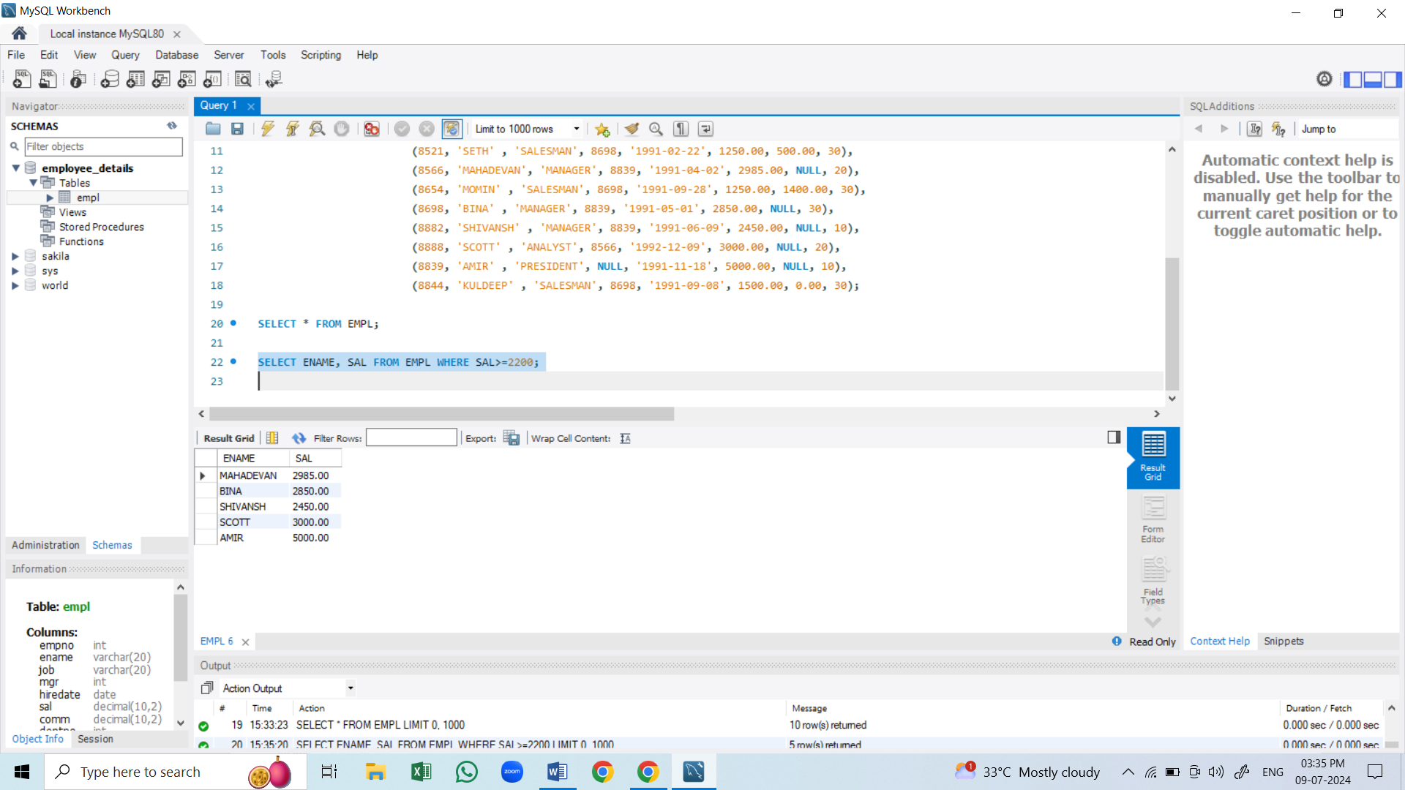

B: Write a query to display details of employee who are not getting commission?

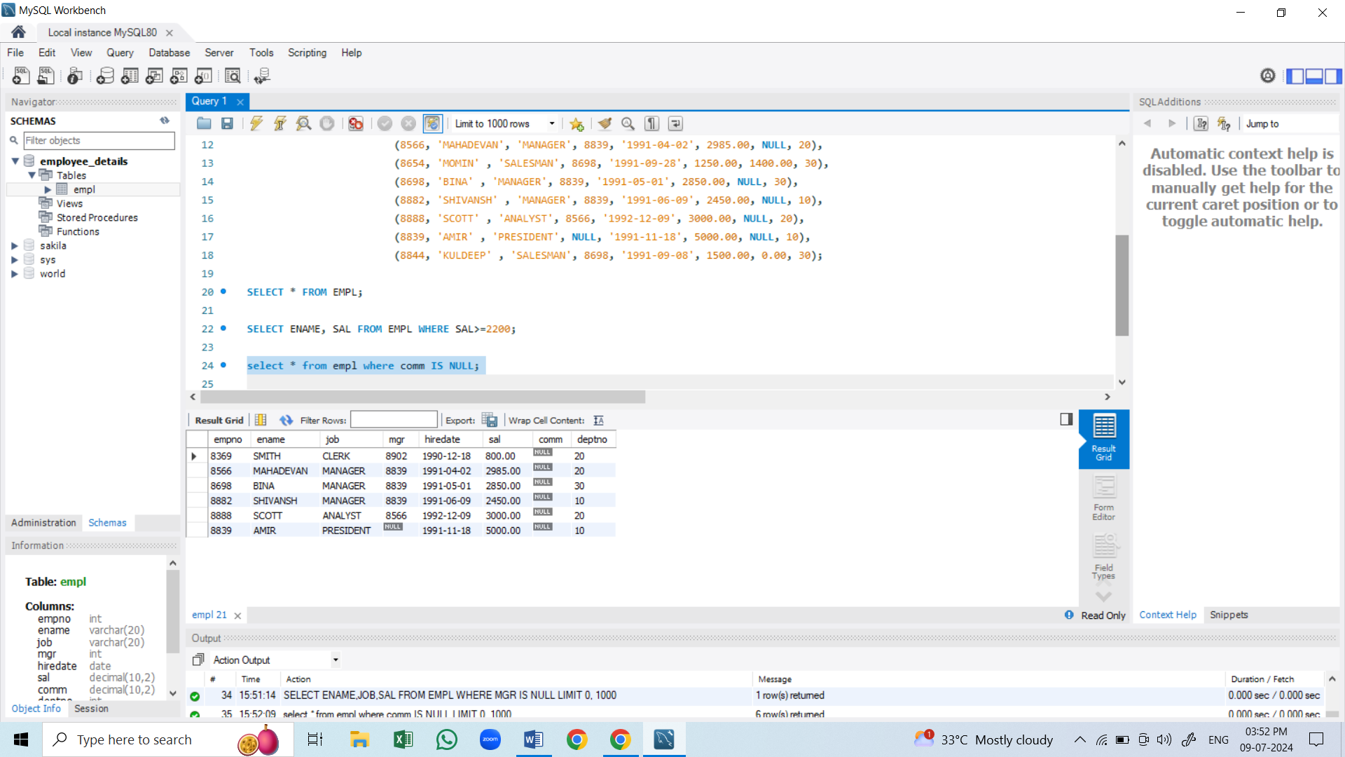

C: Write a query to display EMP name and salary of those who don’t have their salary in the range of 2500 to 4000

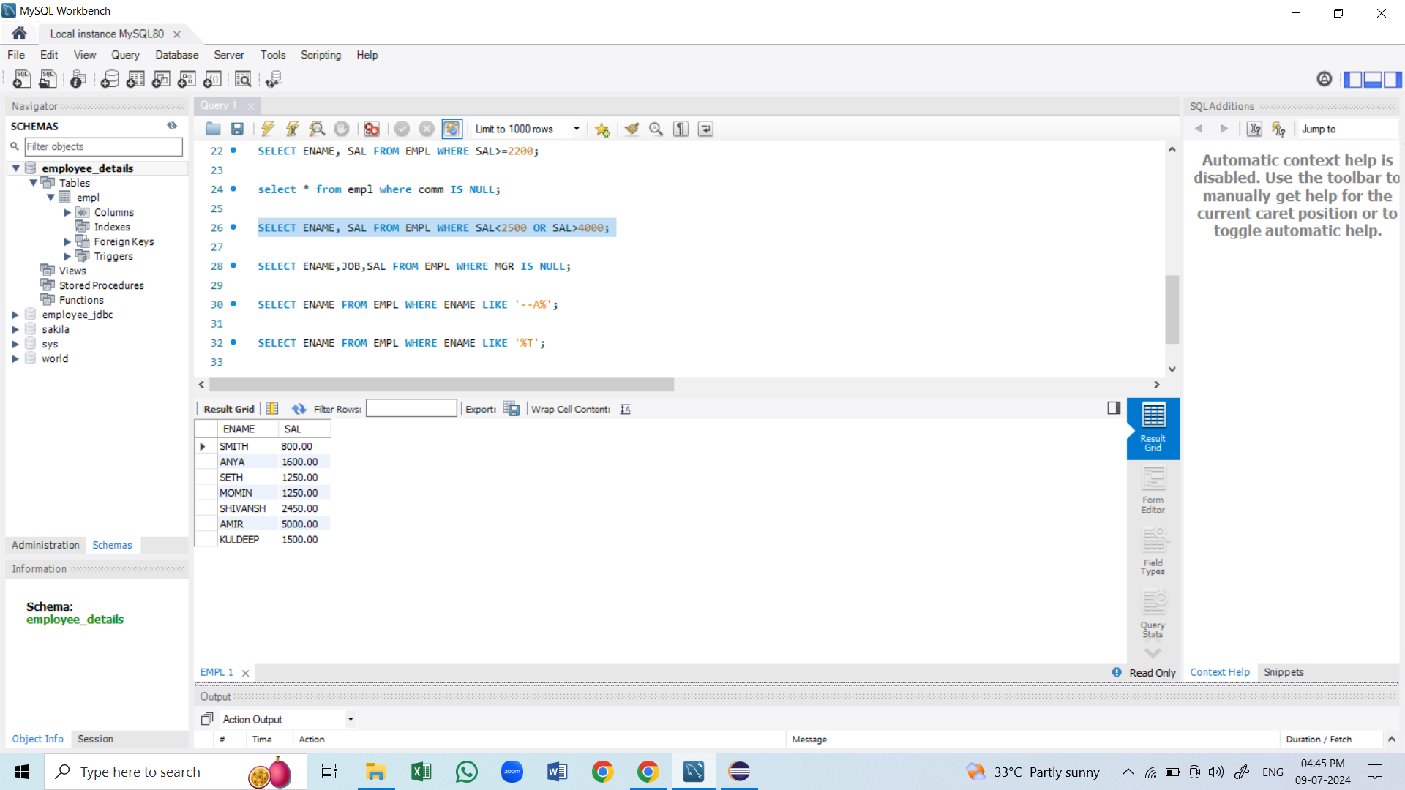

D: Write a query to display the name, job title & salary of employees who don’t have a manager

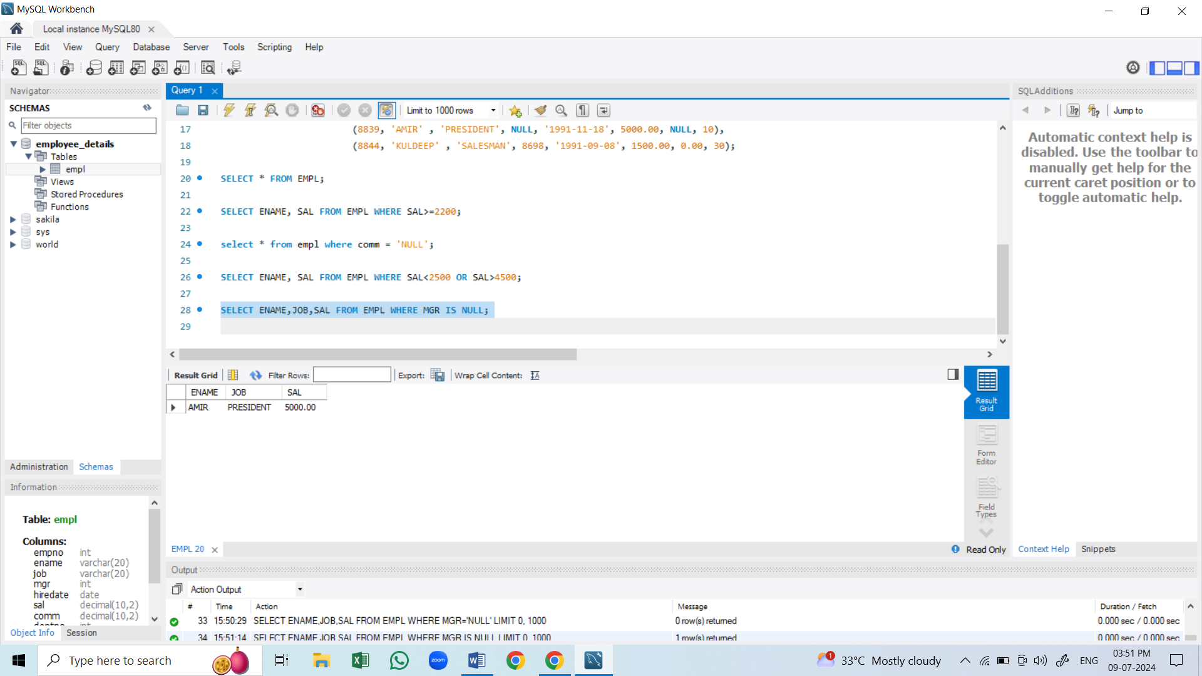

E: Write a query to display the name of an employee whose name contains ‘A’ as third alphabet

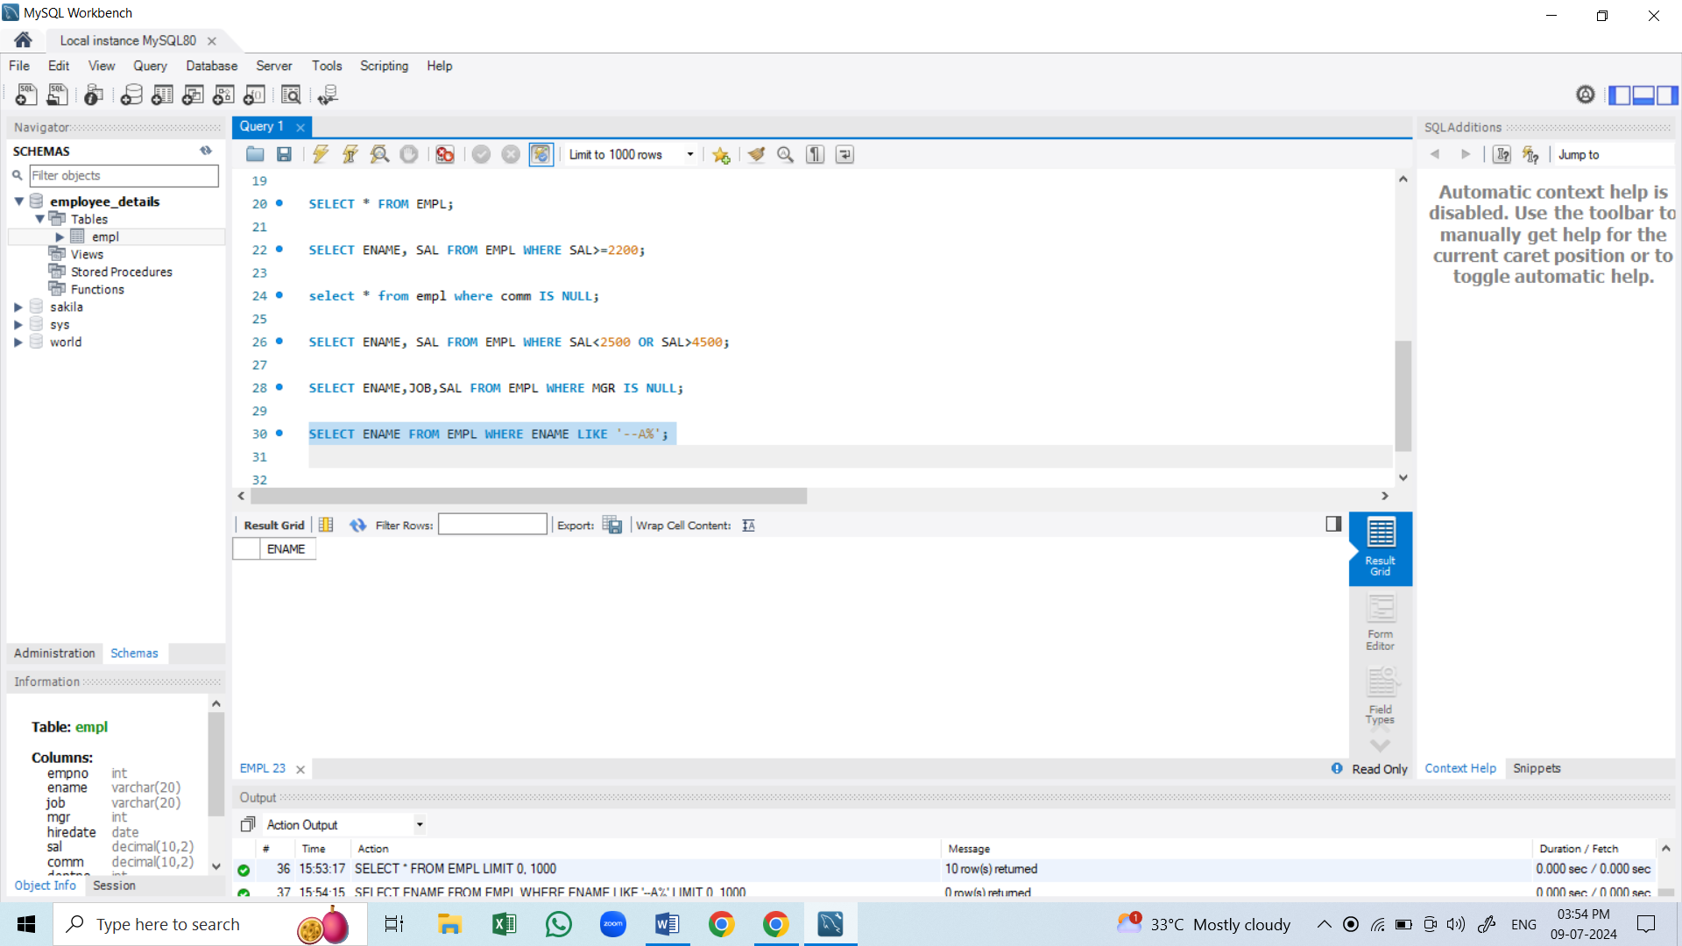

F: Write a query to display the name of an employee whose name contains ‘T’ as the last alphabet

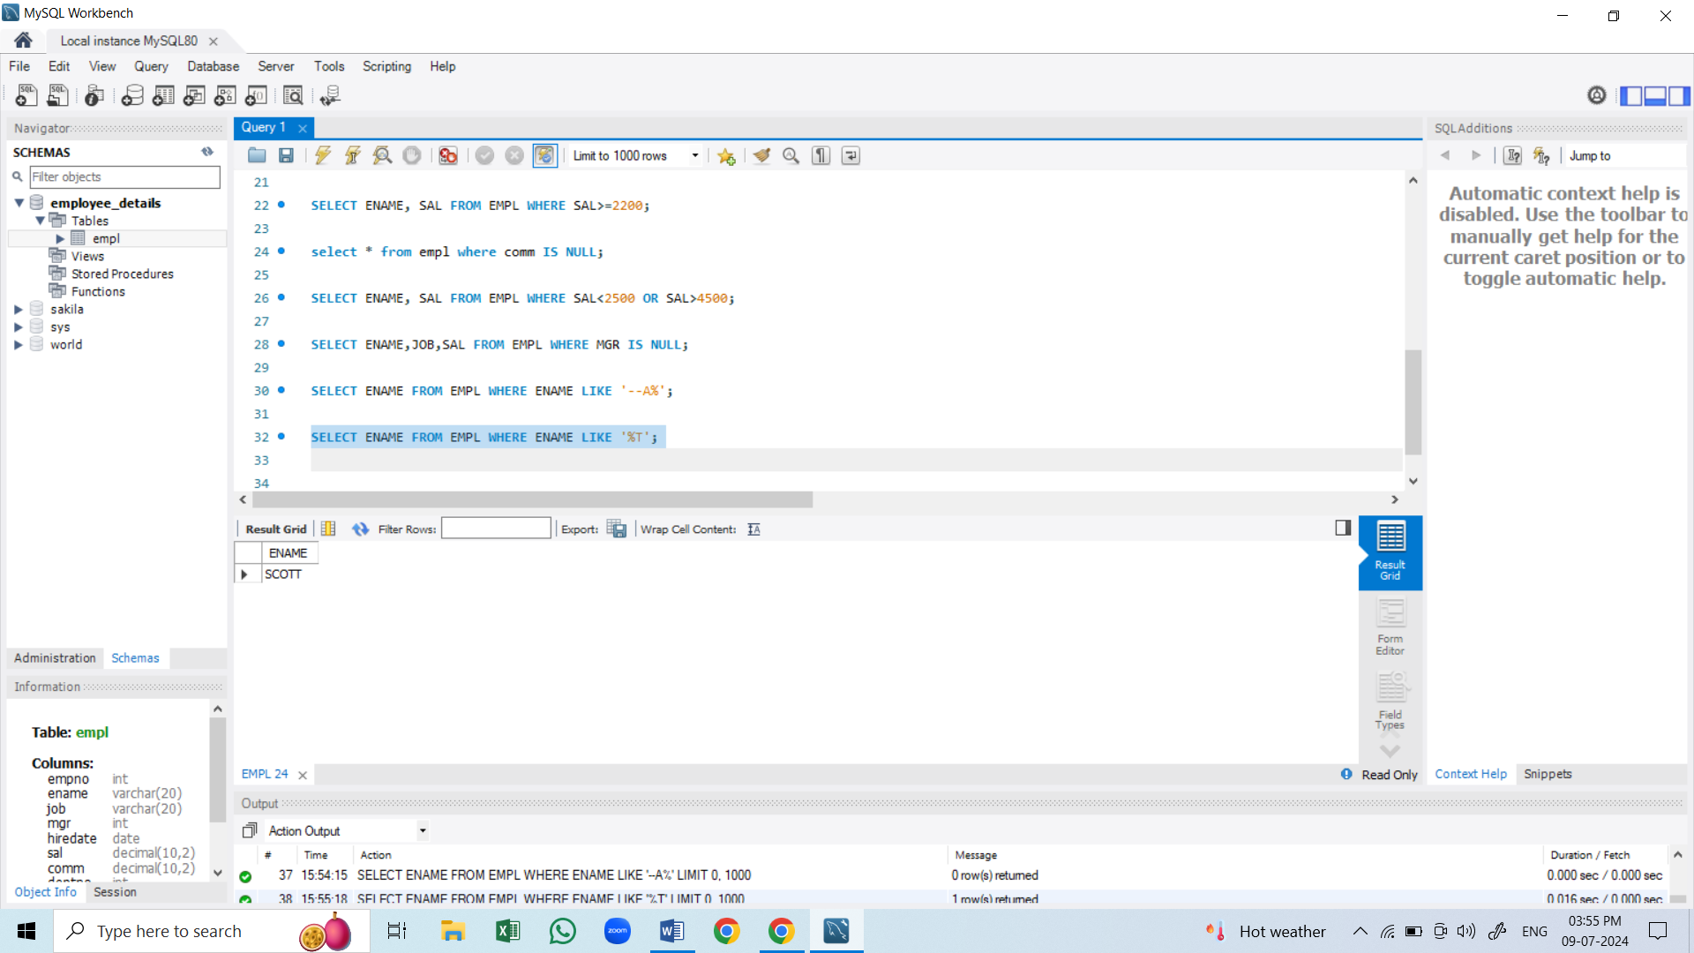

Question 2:

